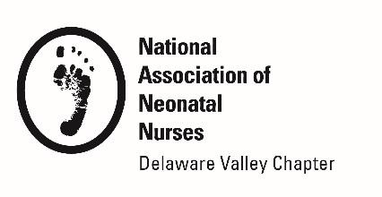

INTERNATIONAL COMMUNITY SERVICE AWARD
APPLICATION

Purpose:

- To recognize and encourage nurses who provide volunteer outreach health assessment, treatment and/or education to the international community. The award will honor and recognize one nurse who is participating in a global outreach program or event which aids in the well-being of family centered care (mothers, fathers, and children).

Requirements
A nominee should:

- Be a current NANN and DVANN Member
- Provide evidence of registration and/or participation in a volunteer global outreach program from 2017-2018
- Community Investment: Volunteer participation in a global outreach program or event which includes health assessment, community intervention, and/or educational experience. This opportunity for professional advocacy and human compassion supports the mission of the Delaware Valley Association of Neonatal Nurses.

Award Recognition:
- $500 award
- Recognition in DVANN’s Preemie Press
- Opportunity to share your experiences in a DVANN-sponsored educational event

Receipt of Application:

- A confirmation email will be sent to nominator’s email address upon application

Deadline and Submissions:
- Please complete application form and submit all required material to
dvannurses@gmail.com

Submission Deadline is November 8, 2019

INTERNATIONAL COMMUNITY SERVICE AWARD
APPLICATION

Name/Credentials

Job Title

Affiliation

Mailing Address

Phone

DVANN Membership Expiration NANN Membership Expiration

Email

Signature/Date

Check here to confirm this is VOLUNTEER program or event

Please attach a copy of the program or event corporation flyer or letterhead

Name of Sponsoring Organization

Address

Telephone Contact

Email

Program or Event Dates

International Location

INTERNATIONAL COMMUNITY SERVICE AWARD
APPLICATION

International Community Service Program or Event Description

- In 250 words or less, explain why you chose to participate in this event.

- What are your goals for this event?

- How do you plan to use this event to enhance your professional growth?

